**Least-squares Algorithm**

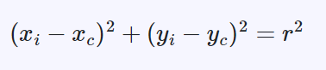

Equation of circle:

* $x_{c}$ is the x-coordinate of the center of the circle
* $y_{c}$ is the y-coordinate of the center of the circle
* $r$ is the radius of the circle

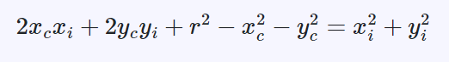

Rearrange the circle equation

Let’s suppose:

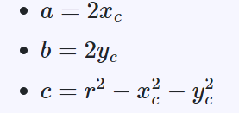

Substitute a, b, c in circle equation.

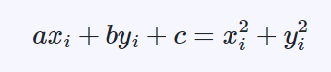

The whole system (for all the points) can be rewritten as:

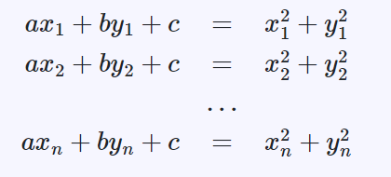

The matrix form of the system is given by:

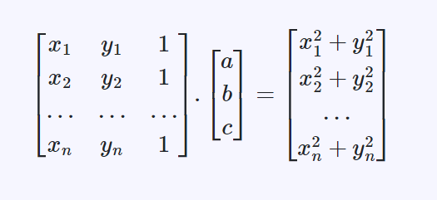

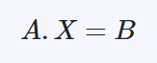

Solve the system for X:

$$X=A^{-1}B$$

Find the center and radius from X:

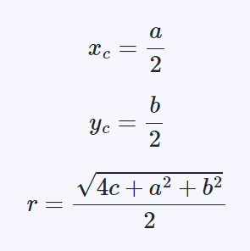

**MATLAB CODE:**

%% Measurement Results (unit: mm)

Points=[75.048 12.019

66.332 44.536

42.542 68.323

10.004 77.000

-22.465 68.329

-46.265 44.514

-54.999 12.022

-46.275 -20.490

-22.475 -44.254

10.035 -52.955

42.524 -44.278

66.323 -20.458

75.030 12.034];

%% Find Centriod and Radius of circle

% Guess Center of the circle

C = [5 , 20];

% Guess Raduis of the circle

R = 60;

% uncertainty of x and y coordinates is 20 µm convert to mm

k = 0.002;

%lenght of the Measurement Results

l=length(Points);

%Matric A = [x1, y2, 1] there will same number of row as x have

A = [Points(:,1) Points(:,2) ones(l,1)];

%Matric A = [x1^2, y2^2] there will same number of row as x have

B = [Points(:,1).*Points(:,1) + Points(:,2).*Points(:,2)];

% solve equation for Unknown

X=pinv(A)*B;

% Find the value of center and radius

xc = X(1)/2;

yc = X(2)/2;

r = sqrt(4*X(3) + X(1)*X(1) + X(2)*X(2) )/2;

fprintf("\nThe Center of circle is: ( %f , %f ) ",xc,yc)

fprintf("\nThe Radius of circle is: %f \n",r)

%% Uncertainty calculation

% Add Uncertainity with point to get Uncertianty in centriod

x1=Points+k;

A = [x1(:,1) x1(:,2) ones(l,1)];

B = [x1(:,1).*x1(:,1) + x1(:,2).*x1(:,2)];

X=pinv(A)*B;

% Gives centriod when the Uncertianity is added

xc1 = X(1)/2;

yc1 = X(2)/2;

% Substract center from Uncertianity center

un_x= abs(xc1-xc);

un_y= abs(yc1-yc);

% Formula for Uncertianity of Radius

un_r= (k^2+k^2)^(1/2);

fprintf("\n\nUncertainty in the Center of circle is: ( %f , %f ) ",un_x,un_y)

fprintf("\nThe Uncertainty in the Radius of circle is: %f \n",un_r)

**Results:**

